升级前提：设备插入SIM卡，4G板能上网
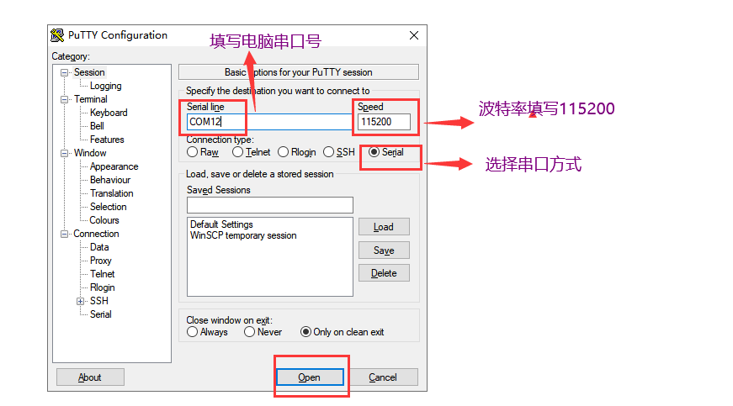
点击OPEN进入超级终端
按回车出现符号： #,如下图：
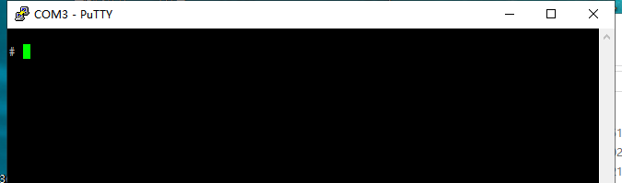
输入指令查看4G板
指令： ifconfig
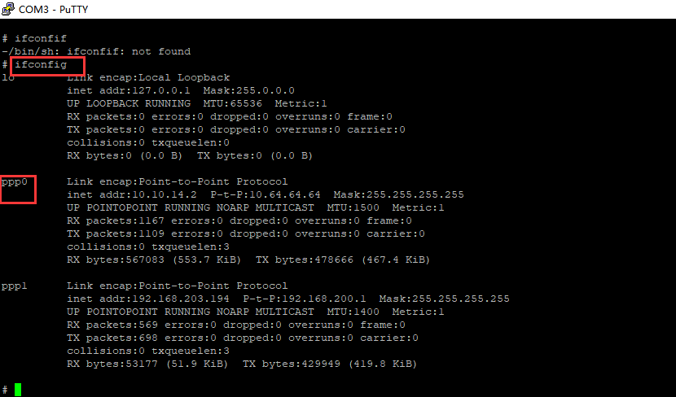
当出现PPP0时说明4G板网络正常，输入4G板升级指令：
指令可以从附件记事本中直接复制：
route add -net 218.205.210.215 netmask 255.255.255.255 dev ppp0
rm /tmp/dgm_upgrade.gz
cd /tmp
wget http://218.205.210.215:81/SO/dgm_upgrade.gz
dgm_upgrade 1>/dev/null 2>&1
cat /etc/config/master_version
killall dgm_ser
echo "info:192.168.88.111" >/tmp/set_scip1
echo "info:9898" >/tmp/set_scport1
echo "info:39.155.243.195" >/tmp/set_vpnip1
echo "info:zc01223" >/tmp/set_vpnuser1
echo "info:dpc01223" >/tmp/set_vpnpsw1
echo "info:39.155.243.195" >/tmp/set_vpnip2
echo "info:zc01223" >/tmp/set_vpnuser2
echo "info:dpc01223" >/tmp/set_vpnpsw2
cat /etc/config/master_version

当看到版本为10.57.2.2时说明软件升级完成
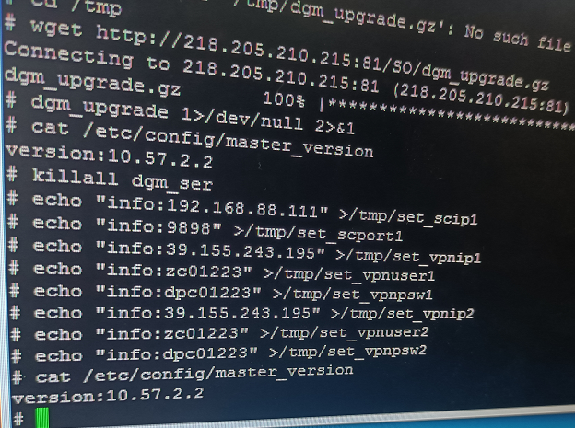

标签修改为：10.57.2.2

